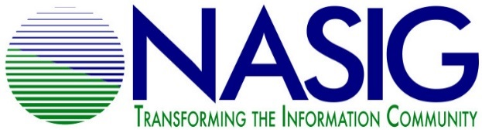
NASIG STUDENT MENTORING PROGRAM
2021 APPLICATION FOR STUDENT MENTEES

Due May 1, 2021

Name: _Evan Reakes____________________________________________
University where studying library/information science OR first professional position/location: _______Marywood____________________________________
Expected date for LIS degree: ____________N/A________________________
Email address: _______ejreakes@maryu.marywood.edu_____________________
Phone number: ___5707099623_____ Address: ____________________________
____________________________
Are you a member of NASIG? (Required; student membership is free)
Yes__Yes___ No_____

The NASIG Mentoring Program requires a one year commitment of participation from mentees. This year’s program will run from June 2021 to May 2022. Will you be able to commit to this timeframe?
Yes_Yes No_____
See the program description for specifics about program participation.
Why do you want to be mentored? What would be your expectations of this program?

I want to be mentored in respect to gaining insight into Electronic resource management specifically, databases, link resolvers, and proxyservers. I think an apprenticeship is one of my preferred methods for learning. A great quotes says, “when one teaches, two learn.” Not only would I be learning but also teaching from my expierences and insights. I have recently been hired at Marywood Univirsty in Scranton PA to be a serials assistant. The university is transitioning with a newer staff and I would love to be able to learn from someone outside of our circle. I have been learning a lot from books and some hands on expiernce with EBSCONet as well as our LCS, Koha. My mentor would not need to be using these. I have a background in information systems and am able to think with the left and right brain. I understand I am late to apply. In any regard thank you for your time.

Areas of Interest (please choose up to 3):
___ Cataloging/Metadata ___ Scholarly Communication
___ Technical Services ___ Public Services
___ Resource Sharing __3_ Electronic Resources
__1_ Linked Data and Usability ___ Access & Discoverability
___ Collection Development/Assessment ___ Serials Management
___ Preservation/Digital Perservation ___ Open Access
___ Industry Standards ___ Licensing
_2__ Library Web Site Development ___ Accessibility/Diversity Iniatives
___ Usage Statistics ___ Institutional Repositories

Please list any other relevant areas of interest that are not mentioned above.
Anything in respect to information technology. Systems administration, networks, databases, statistics.

Would you like to be mentored on research and publication?
Yes_____ possibly? No_____

Is there any other information that you would like to add to this application?
Thank you for your time and energy.

Please email your completed application by May 1, 2021 to daniellenasig@gmail.com
By submitting this form you aknowledge that you will actively participate in the program, will strive to be respectful and constructive in all communication. The Student Outreach Committee will be contacted if issues/concerns arise that the mentor or mentee are not able to resolve on their own. All discussions and information will be kept confidential unless otherwise specified by the both the mentor and mentee.

